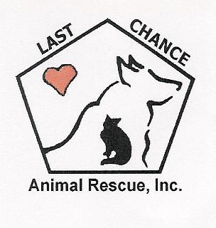**SPAY AND NEUTER POST-OPERATIVE CARE INSTRUCTIONS**

**THE SPAY SPOT**

**3750 BROWN STATION RD**

**Upper Marlboro, MD 20772**

**301-254-8151**

Your pet has just had major surgery and will require some extra care while recovering. When you return home, please follow the below instructions:

* Restrict an adult pet’s food intake to avoid stomach upset from anesthesia. Do not offer adult pets any food for the first 2 to 3 hours. After 2 to 3 hours you may offer food in very small amounts for the first 12 hours, but do not be concerned if your pet does not want to eat right away. Remove food until morning if vomiting occurs. Offer normal amounts of water.
* Kittens and puppies can be offered food and water upon returning home.
* Keep your pet in a clean environment that is quiet, warm, and dry. House your pets indoors. Keep the pet in a confined area away from other pets and children for 14 days. Do not place them in a high place (bed, sofa, etc.) and keep them away from stairs. Rest and sleep are essential for healing.
* Monitor regularly to ensure **E-Collar** is prohibiting your pet from licking/chewing at the incision site. At first when using an E-collar, prepare for them to react negatively at first. It will be awkward for them, and hinder their movement. It usually takes pets 24 hours to get used to the collar, but then they are quite accepting of it. **Please note that repairing any self-inflicted damage to the incision site will be at the owner’s expense.**
* Brief leash walks are allowed for urination and defecation purposes only. Restrict your pet’s activity, no running, jumping or rough play. Your pet must return immediately for cage rest.
* If pain medication has been prescribed, please follow the written instructions carefully. Do not give Aspirin, Advil or Tylenol to your pet for pain relief. **These medications can be deadly.**
* A small amount of blood around the incision is normal immediately after surgery.
* Check your pet’s incision daily. A small amount of redness and swelling is normal. Do not allow your pet to lick the incision site. Keep the E-collar on at all times unless you are going to be with your pet to ensure that he/she does not lick at the incision.
* Do not wash or clean the incision. Do not bathe or get your pet wet for 14 days.

**Please call our veterinarian at 240-682-4494 and leave a message if your pet exhibits the following symptoms within the next 24 to 48 hours:**

* Your pet is unable to stand or walk 12 hours after surgery.
* Your pet is not eating or drinking 24 hours after surgery.
* There is significant swelling or bleeding at the incision site. A firm, small swelling under the skin is generally a normal inflammatory response to surgery and will get smaller over several weeks. A lump that is soft or accompanied by fever or lethargy should be seen.
* Your pet is exhibiting symptoms of significant discomfort or lethargy 48 hours after surgery.

**After 48 hours, call us during our normal business hours, or if you think it is an emergency call one of the emergency clinics in your area.**